Jenkin installation



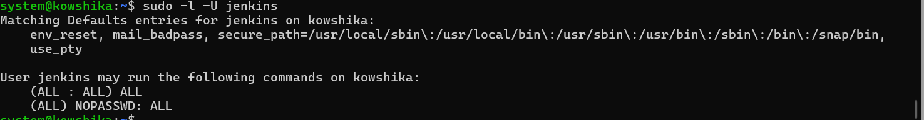

Java installation



Nginx installation

